EX01- ARMSTRONG NUMBER
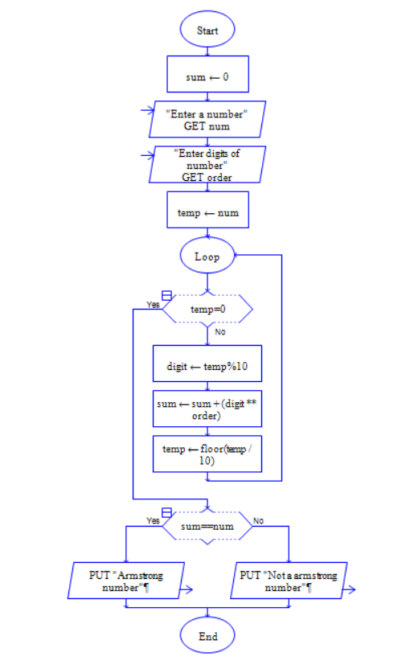

EX02- GREATEST OF THREE NUMBERS
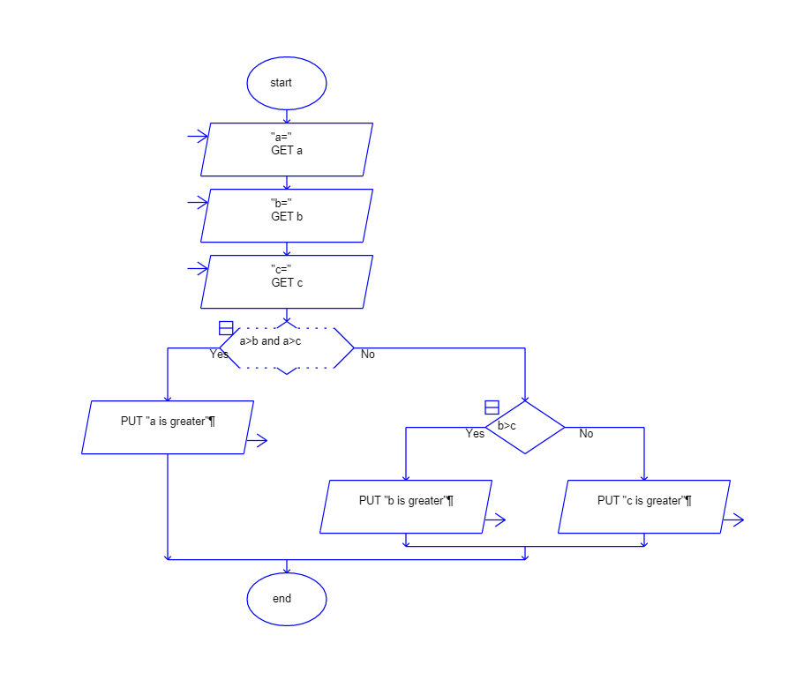

EX03- FACTORIAL OF A NUMBER

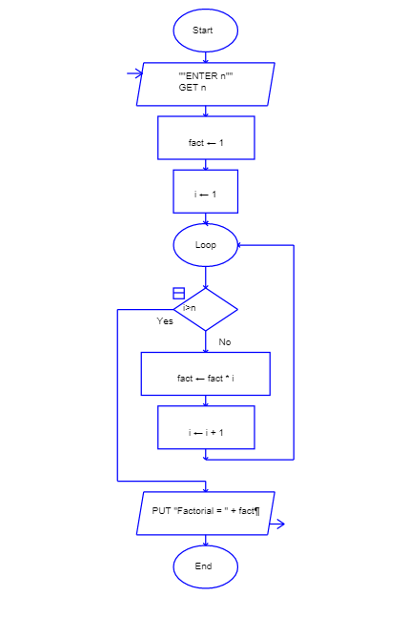

EX04- FINDING THE TOTAL NUMBER OF CHARACTERS IN A STRING
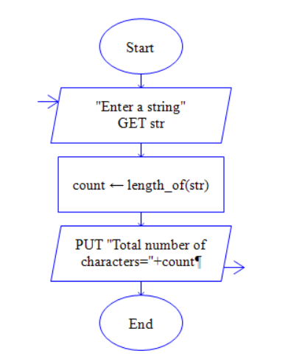

EX05- FINDING THE LEXICOGRAPHICALLY SMALLEST STRING BY SWAPPING ANY TWO CHARACTERS USING RAPTOR

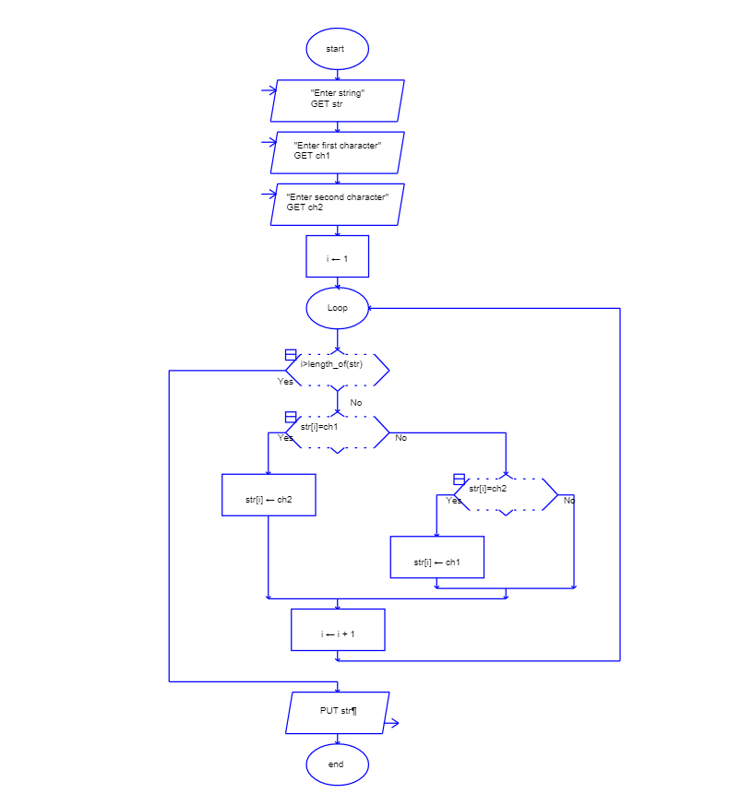

EX06- CALCULATION OF CYCLOMATIC COMPLEXITY OF A FLOW GRAPH

